Box-Cox Power Transformation

The aim of using the Box-Cox power transformation is to ensure the data follows an approximately normal distribution. That is, 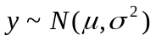. A normal distribution assumption is necessary for the use of the robust fractional differencing Whittle estimator.

Box-Cox Power Transformation:

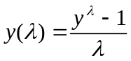 if 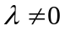 and 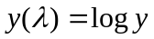 if 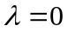

The y’s (i.e. observations) must be strictly positive (>0). If not, the absolute value of the minimum observed data value plus a small epsilon can be added to each observation to make the data set all > 0.

Methodology:
- Test original series for normality.
- Apply the Box-Cox test to determine appropriate power (λ) and its standard error to use.
- If the interval (λ ± std. error) contains 0, a power of 0 or log transformation was applied to the data. Else, the estimate λ or its closest fraction is used to transform the data.
- Apply the determined Box-Cox power the series.
- Perform formal statistical normality tests for the Box-Cox power transformed series.
- Plot density plots of the Box-Cox power transformed series to ensure normality.

Cautions of the Box-Cox transformation:
The Box-Cox transformation attempts to apply a power transformation to the data set to make the distribution as normal as possible. However, if the true distribution is far from normal, a Box-Cox transformation will not be sufficient.

However, even in cases where no power transformation could bring the distribution to exactly normal, the usual estimates of λ will lead to a distribution that satisfies certain restrictions on the first 4 moments, thus will be usually symmetric (Draper and Cox, 1969).
Example: Nile River data

Box-Cox test for the Nile River data suggests that a log transformation (power of 0) of the data would result in a normality distribution.

Box-Cox Transformation to Normality

Est.Power Std.Err. Wald(Power=0) Wald(Power=1)
-0.0676 0.4165 -0.1622 -2.5633

L.R. test, power = 0: 0.0263 df = 1 p = 0.8711
L.R. test, power = 1: 6.6113 df = 1 p = 0.0101

Normality tests for the original vs. log transformed Nile data:
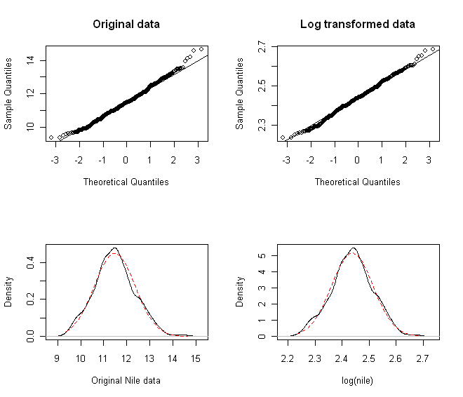

Summary of results of the Box-Cox test to the OFHEO state-level housing price data

